Networking Concepts
Routing, VLAN, and TCP/UDP — Easy Study Notes
Reorganized from Lecture 10 for simple and complete reading

What This Note Covers
- 1. Routing — what a router does and how it picks a path
- 2. Routing Protocols — static vs dynamic, and common protocol names
- 3. Internetworking Devices — hub, bridge, switch, router
- 4. VLAN — virtual networks and their benefits
- 5. TCP/UDP — the two main transport protocols
Note: Each topic is short and simple on purpose. Read it once, and you will cover everything in the original slides.

1. Routing

1.1 What Is a Router?
A router is a device. Its job is to decide the next point where a data packet should go, so the packet can reach its final destination.
- A router lets different networks talk to each other.
- A router keeps a table of all the routes it knows, along with their condition. It uses this table to pick the best route for each packet.
- A packet usually passes through several routers before it reaches its destination.
- If there are many possible routes, the router picks the one with the lowest weight (also called metric) first.
Note: Think of a router like a traffic signal for data. It always looks for the shortest and safest path.

1.2 How Routing Looks in a Network
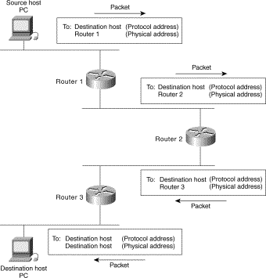
Figure 1: A simple picture of how routing connects different networks together.

1.3 Routing Protocols
A routing protocol is a set of rules that routers use to share route information with each other. There are two main types.
- Static Routing — the route is set by hand. It does not change on its own.
- Dynamic Routing — routers learn routes automatically and update them when the network changes.
Dynamic routing protocols are further grouped by where they work:
- IGP (Interior Gateway Protocol) — sends route data inside one autonomous system (one organization's network). Examples:
  - RIP (Routing Information Protocol)
  - RIP-2 (RIP Version 2)
  - OSPF (Open Shortest Path First)
  - IGRP (Interior Gateway Routing Protocol)
  - EIGRP (Enhanced Interior Gateway Routing Protocol)
  - IS-IS
- EGP (Exterior Gateway Protocol) — sends route data between different autonomous systems. Example:
  - BGP (Border Gateway Protocol)
Note: An autonomous system just means one network that is managed by one organization, like a company or an internet service provider.

2. Internetworking Devices
These are the main devices used to build and connect networks. Each one works at a different level and has a different job.
Device | What It Does
Hub | Connects many devices to one network. It repeats and resends the signal to all ports, without checking where it should go.
Bridge | Splits one network into smaller parts. It works at Layer 2 (data link layer) and does not depend on higher-level protocols.
Switch | Works like a bridge but has more ports. Each port is its own separate segment, so it reduces data collisions and improves speed.
Router | Connects different networks and separates broadcast traffic. It sends data based on the network address (Layer 3), not the device's hardware address.

Note: Simple way to remember: Hub = repeats to everyone. Bridge/Switch = splits traffic smartly. Router = connects separate networks.

3. VLAN (Virtual LAN)

3.1 What Is a VLAN?
A VLAN lets network managers group users by logic, such as their job, project, or the application they use, instead of grouping them by physical location.
- Data can only move between VLANs through routing.
- VLANs do the same job that physical routers used to do — they divide a LAN into smaller, separate parts.

3.2 VLAN and Inter-VLAN Routing
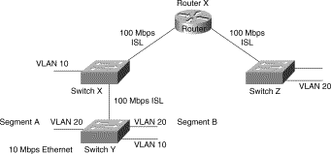
Figure 2: VLANs are separate groups. A router is needed for them to communicate with each other.

3.3 Why Use VLANs?
- Broadcast Control — Just like switches keep collision traffic separate, VLANs keep broadcast and multicast traffic inside their own group.
- Security — If routing is turned off for a VLAN, users outside that VLAN cannot reach users inside it, and the other way around. This gives strong protection for sensitive projects.
- Performance — Users who need faster or separate networking can be placed in their own VLAN.
Note: VLANs are useful because they give the benefits of separate physical networks, without needing separate physical cables.

4. TCP / UDP
TCP and UDP are both Transport Layer protocols. This layer is responsible for moving data between two devices.
Feature | TCP | UDP
Connection Type | Connection-oriented (a link is set up before sending data) | Connectionless (data is sent with no set-up)
Reliability | Uses checksum and acknowledgment to check and confirm delivery | No delivery check; faster but less reliable
Port Number | Uses a 16-bit source and destination port number | Uses a 16-bit source and destination port number

4.1 Standard Port Numbers
Common applications always use the same port number, so devices know which service to connect to.
- Email — Port 25
- Telnet — Port 23
- FTP — Ports 20 and 21
- SSH — Port 22
Note: TCP is used when accuracy matters, like sending a file. UDP is used when speed matters more than perfect accuracy, like video calls.

Quick Summary
- Routing moves packets across networks using the best path.
- Routing protocols can be static (fixed) or dynamic (self-updating), and are grouped as IGP or EGP.
- Hubs, bridges, switches, and routers each connect networks in a different way.
- VLANs group users logically for better control, security, and performance.
- TCP is reliable and connection-based. UDP is fast and connectionless.
Note: Reading this summary after the full notes is a good way to check what you remember.

